Faculty Exchange Programme
Participating Department: Department of Geography and Zoology
Date: 22nd April, 2022
Venue: Department of Geography, Mangaldai College
Theme: Significance of Observing Earth Day
Resource Person: Bikash Rabha, Assistant Professor, Department of Zoology
Participants: All Students of Department of Geography
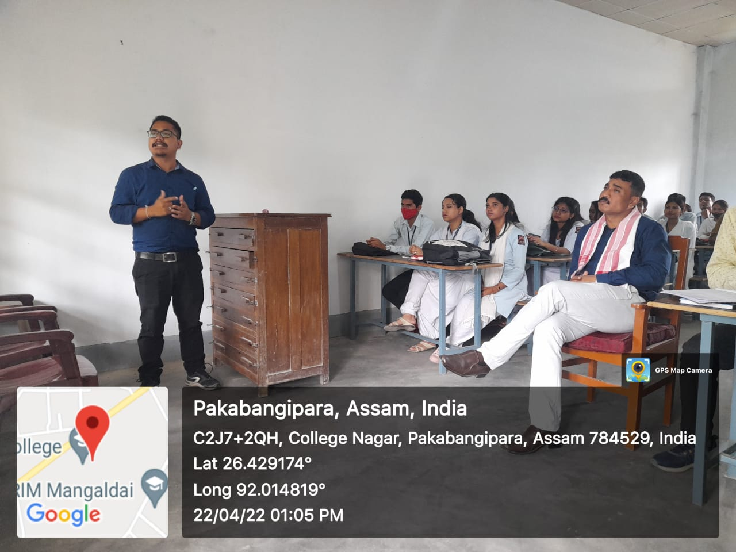

Record of Departmental Proceeding
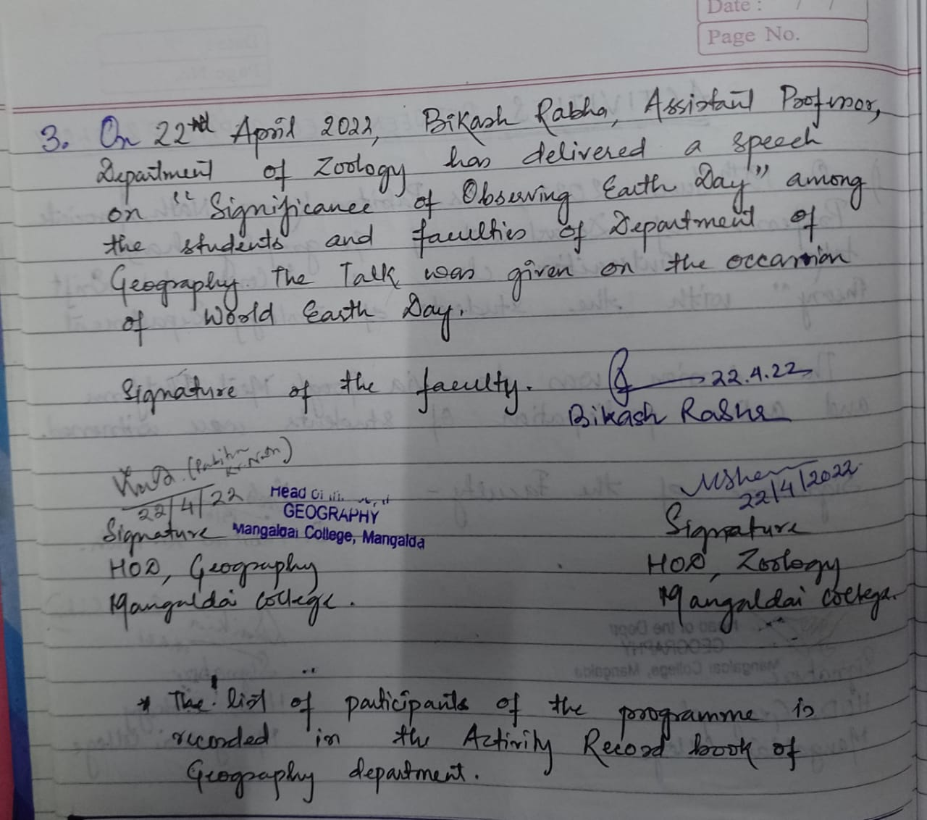

Faculty Exchange Programme
Participating Department : Department of Geography and Zoology
Date: 10th June, 2022
Venue: Department of Geography, Mangaldai College
Theme: Genetic classification of diseases
Resource Person: Dr. Minati Sarma, Associate Professor, Department of Zoology
Participants: 6th Semester Major students, Department of Geography

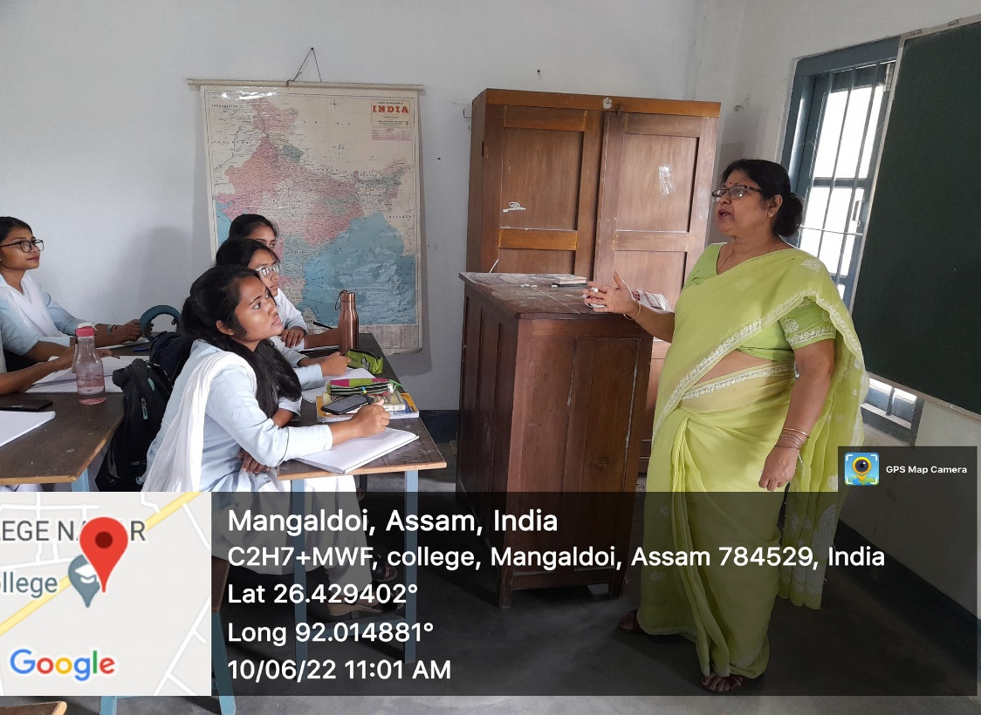

Record of Departmental Proceeding
